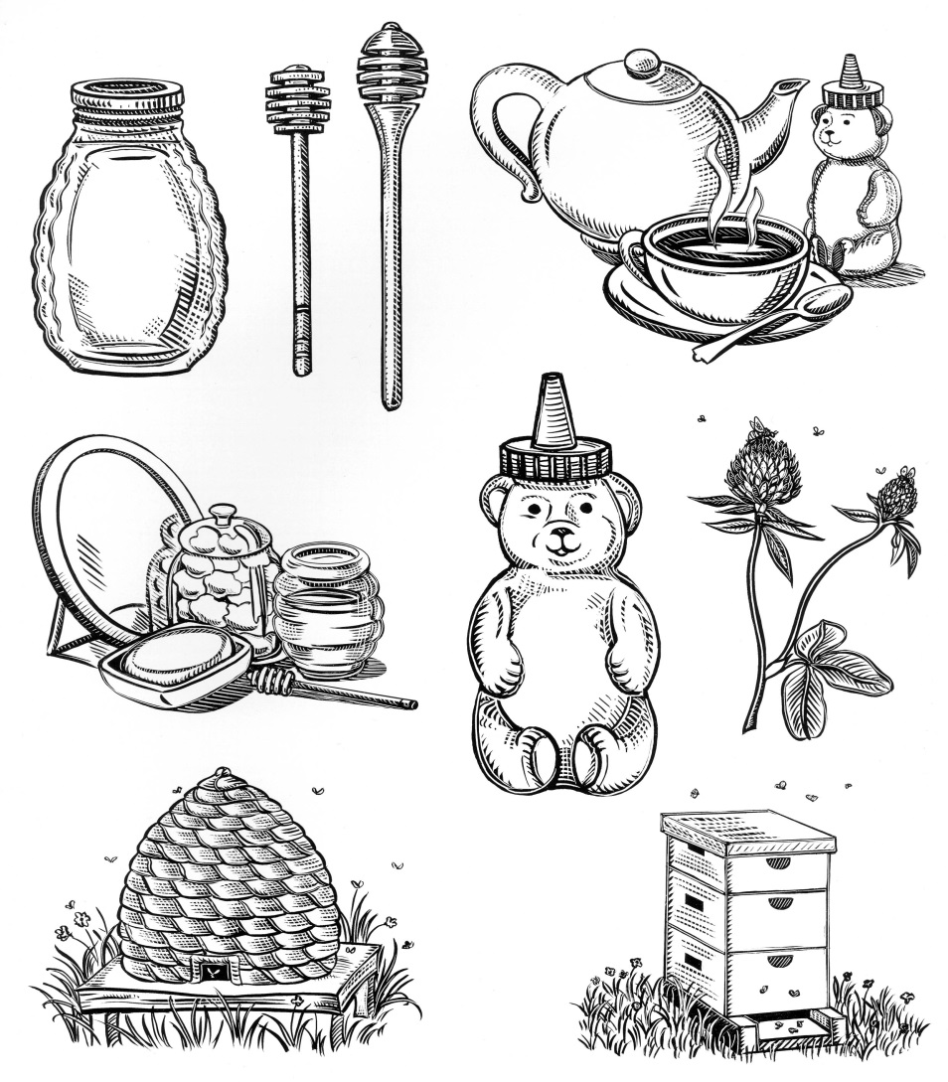

Selling Honey

SWAFMC Markets have a special provision for members of **Southwest Arkansas Beekeepers to sell honey and other bee products** free of charge in the "stall" paid for by the beekeeping association. Beekeepers who are members of Southwest Arkansas Beekeepers must register and abide by all other rules of the market, but do not have to pay *individual* fees to sell their bee products. The club may also sell bee-related objects at market and use the stall to promote awareness of bees and beekeeping.

Beekeepers wishing to sell other farm products, baked goods, etc. and beekeepers who are not members of the above beekeeping associations must pay the same fees as other growers and may sell any items other market growers may sell (i.e. they are NOT limited to honey and bee products.)

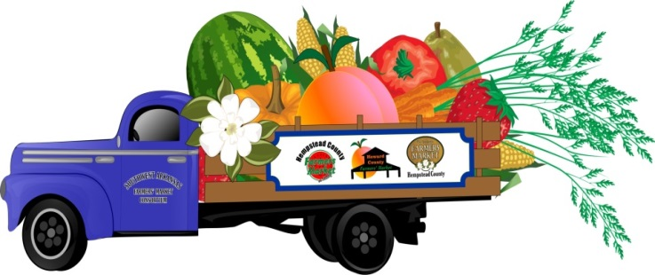

Selling Honey

SWAFMC Markets have a special provision for members of **Southwest Arkansas Beekeepers to sell honey and other bee products** free of charge in the "stall" paid for by the beekeeping association. Beekeepers who are members of Southwest Arkansas Beekeepers must register and abide by all other rules of the market, but do not have to pay *individual* fees to sell their bee products. The club may also sell bee-related objects at market and use the stall to promote awareness of bees and beekeeping.

Beekeepers wishing to sell other farm products, baked goods, etc. and beekeepers who are not members of the above beekeeping associations must pay the same fees as other growers and may sell any items other market growers may sell (i.e. they are NOT limited to honey and bee products.)

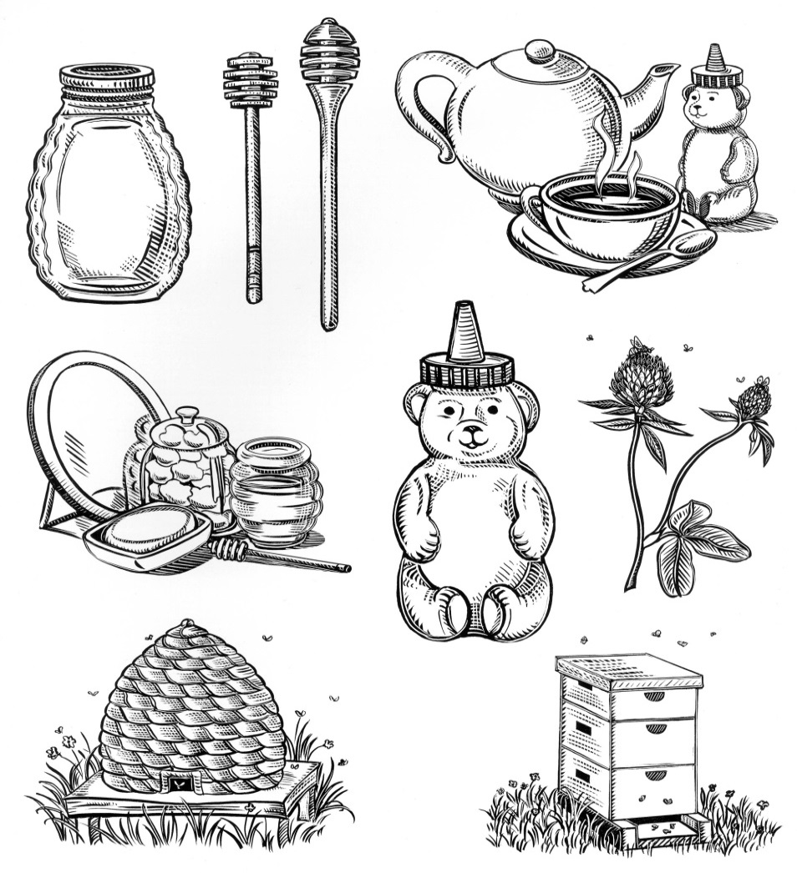

Selling Honey

SWAFMC Markets have a special provision for members of **Southwest Arkansas Beekeepers to sell honey and other bee products** free of charge in the "stall" paid for by the beekeeping association. Beekeepers who are members of Southwest Arkansas Beekeepers must register and abide by all other rules of the market, but do not have to pay *individual* fees to sell their bee products. The club may also sell bee-related objects at market and use the stall to promote awareness of bees and beekeeping.

Beekeepers wishing to sell other farm products, baked goods, etc. and beekeepers who are not members of the above beekeeping associations must pay the same fees as other growers and may sell any items other market growers may sell (i.e. they are NOT limited to honey and bee products.)

